|  |
| --- |
| Web Database Application |
|  |
| **A unique web application to satisfy all automotive needs** |
|  |
| **Hassan Ali Mirza**  **Sai Harsha Potluri**  **Mubeen Ahmed Tachi** |
| **12/9/2016** |

**TABLE OF CONTENTS**

1. INTRODUCTION
2. EXISTING SYSTEM
3. FEW PROBLEMS
4. PROPOSED APPLICATION
5. TARGET USERS
6. USER GOALS
7. SYSTEM SPECIFICATIONS
8. HARDWARE SPECIFICTION
9. SOFTWARE SPECIFICATION
10. MODULES
11. REGISTER
12. ADMIN LOGIN
13. LOGIN
14. MAKE AN APPOINMENT
15. PRODCUTS
16. SERVICES
17. MESSAGE CENTER
18. SEARCH
19. CART
20. PAYMENT
21. ABOUT US
22. CONTACT US
23. DOCKS
24. FINAL OUTPUT/SCREEN SHOTS
25. CONCLUSION
26. REFERENCES

**INTRODUCTION**

Automobiles have become a basic need for people these days. We cannot assume a world with mobility automation these days. Not only cars, motor cycles but also most futuristic mobility products started making their way in to market. We can see many automakers are making huge money banks with the booming market for automobiles. So, we as a team decided to design a money making web application which targets all automobile users to have a look.

**EXISTING SYSTEM**

These are many applications regarding auto service and selling auto parts online. Basically, they perform marketing activity for their respective physical service centers. They provide customers all the information regarding available services, offers and enable them to schedule appointment to take their car to service station.

**FEW PROBLEMS**

The number of people who purchase cars, or any sort of automobile has been increasing on a higher growth rate. So, the requirement for auto servicing and selling auto accessories had gone up. But, we felt in the modern world taking out your car to service station is an old idea. Now we are taking this business a step ahead with our proposed application.

**PROPOSED APPLICATION**

For us, making business out of our application had been the focus. Of course may not be now but sometime in the future. Now, we are designing a web application similar to amazon. Here you can select accessories/services and purchase them. Once you confirm your payment, you get your items delivered at your door step. If you needed any sort of service like oil change/tire installation, our service on wheels team will perform service at your place. Basically, we assure all your car needs fulfilled with a simple application

**TARGET USERS**

For our proposed application, this can be a very simple and single line.” EVERYONE WHO HAS GOT A CAR IS OUR TARGET CUSTOMER”

**USER GOALS**

Every user who visits our web application looks for quality accessories and quick service. He will be looking for easy and comfortable navigation through pages. He also looks for simple and attractive design. So, that he should be relaxed and hassle free with using application. He should have the ultimate goal of sorting out his required items and service and finalize his payment without any difficulties.

His goals can be properly achieved by designing an efficient web application. Proposed application is much simpler and easily navigated from one page to another. Load time of website is also very low which does not frustrate the users to wait while looking or checking out their products

**SYSTEM SPECIFICATIONS**

HARWARE REQUIREMENTS

* 2 GB RAM
* 100 GB HARD DISK
* INTEL I3

SOFTWARE REQUREMENTS

* IDE: NETBEANS
* LANGUAGES

1. JSF
2. PRIMEFACES
3. JAVA
4. CSS
5. HTML
6. XML

* DATABASE: MYSQL

**MODULES**

1. ***Register module***

This module is the very first one, a user looks at. It is quite simple to understand and perform. It allows any user to get registered with our application. Now, user can go ahead with his specific tasks. He can get into application completely and use its full functionalities. He will simply need to provide his first name, last name, email and select a password.

1. ***Admin login***

This is a simple and useful part of our application. This is much needed for business to get carried forward. The person who handles the business will act as admin to the application. He will get a proper id/password from developers’ side. He can use it to get into application. He can view the scheduled appointments and accordingly.

1. ***Login***

This is quite similar to that of our “register module”. Say, a user gets registered to our application using “register module”. Now he needs to get logged into the application using this login module. To make it simple, the register user will have drop down his id/password here to enter application. Once, he hits correct, he is into the world of cars.

1. ***Make an appointment***

Now, this is the most important module and also functionality of our application. Our whole idea moves around this concept. Once logged in, a user can schedule an appointment with the management. He will mention all his service needs in the space provided. Once, he schedules this, admin to look it on his side and take actions accordingly. This is the business behind this application.

1. ***Products***

This is one of the important modules in our application. This is also major business tool for the management. Here, we list out all kinds of products available in our warehouse. A logged in customer can view the complete and purchase later on.

1. ***Services***

In this we describe our service packages. Here, a logged in user can look at different services we provide. According to his requirement, he can look for specific service. Now, there he can write down in appointment page and get his job done. Simple, but useful module.

1. ***Message center***

This part is very useful from customer point of view. While, shopping or figuring out his service option, a logged in user can go to message center and communicate instantly with admin.

1. ***Search***

This a simple box space provided at the right corner. A user can type the specific product he is look for. Once, it gets matched he will get directed to that particular page.

1. ***Cart***

Name of this module defines everything. A user can add all his shopped products to this cart. User can add and delete selected products from cart. Once he is done with finalizing cart, he can go ahead for payment

1. ***Payment***

This module comes only after finalization of cart. Once, user finalizes cart he can head to payment modules. There he can pay with cards or PayPal and purchase his products.

1. ***About us***

This is informative part of our application. A small and simple description of basic functions of our application will be presented.

1. ***Contact us***

Name says it all. Complete contact details of management will be provided here. User can view and contact the management accordingly.

1. ***Docks***

It is an attractive bar kind of thing. This goes into to footer. User can easily navigate to all modules using these Docks. All thanks to prime faces.

**SCREEN SHOTS**

In this section you can all the screen shots we captured while working on our projects.

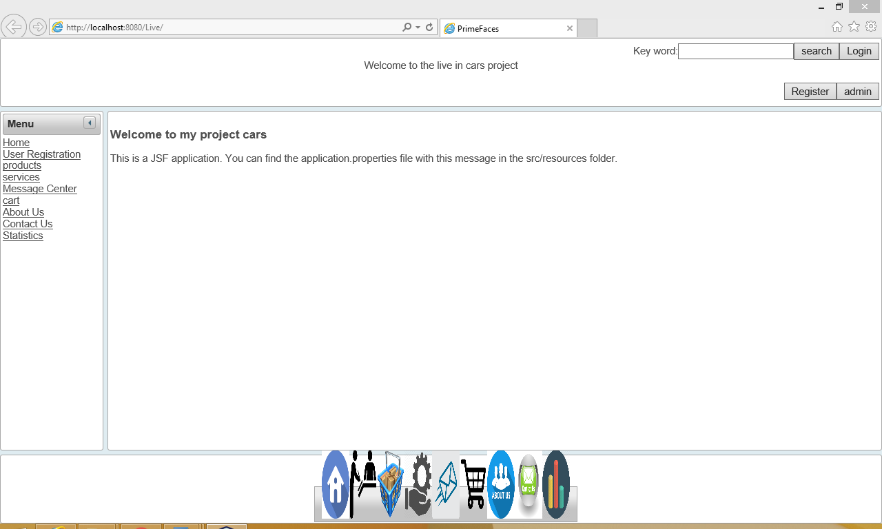

Figure1: Home page of the Application

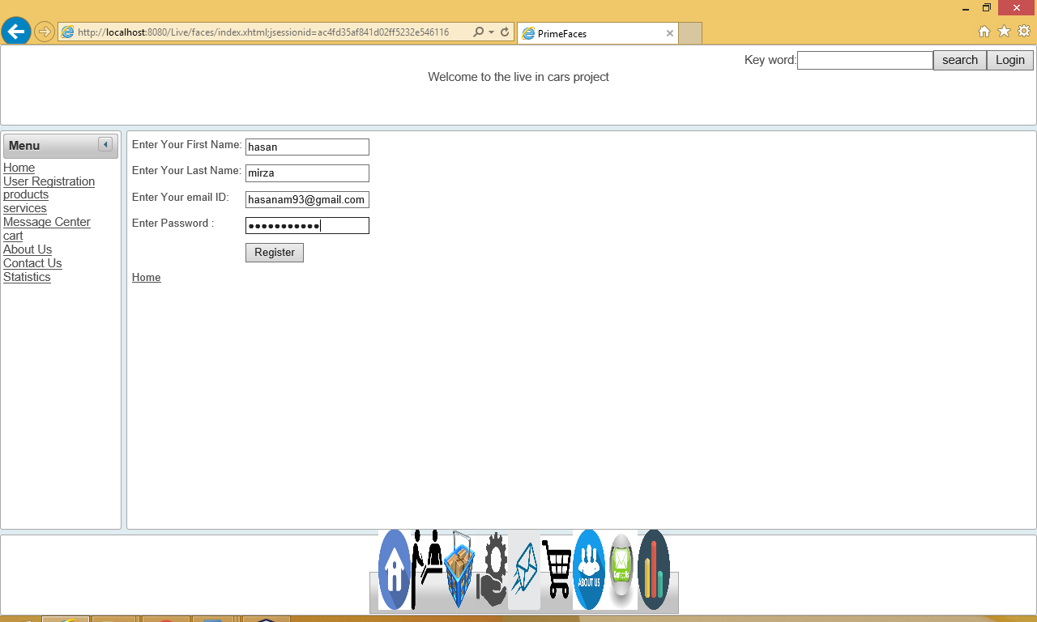

Figure 2: User Registration

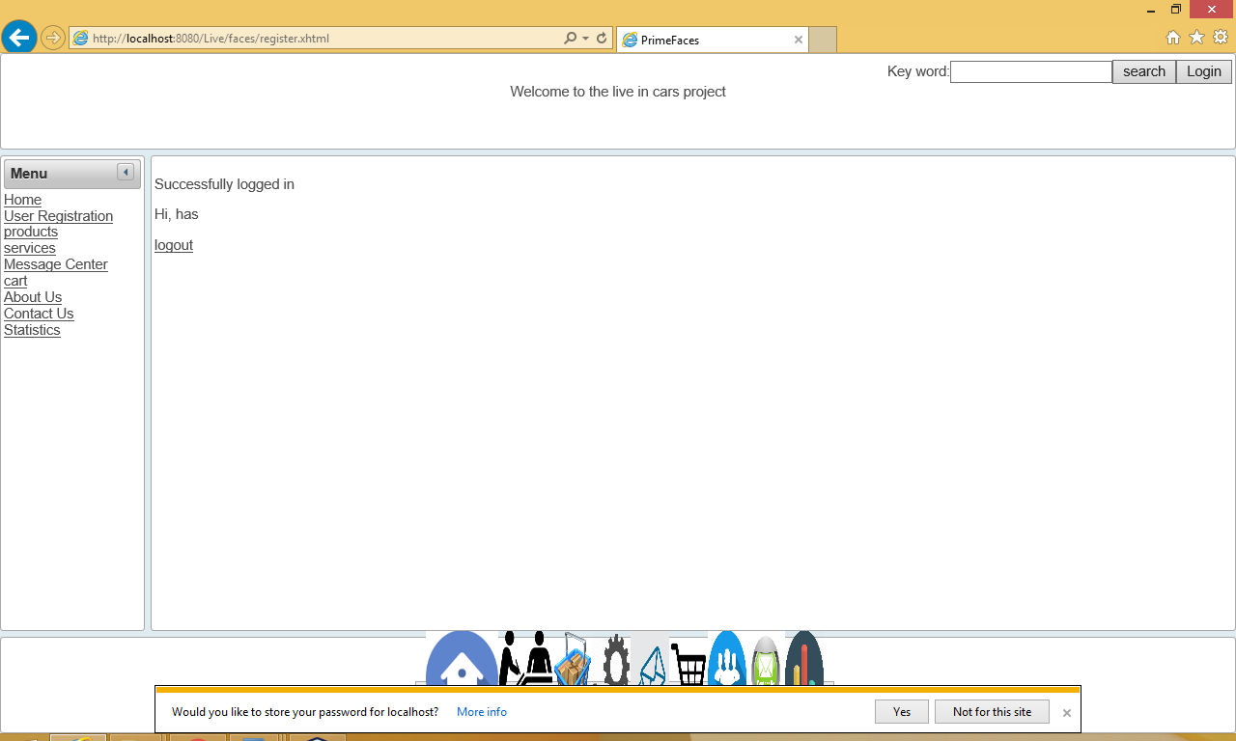

Figure 3: After Registration successfully logged in

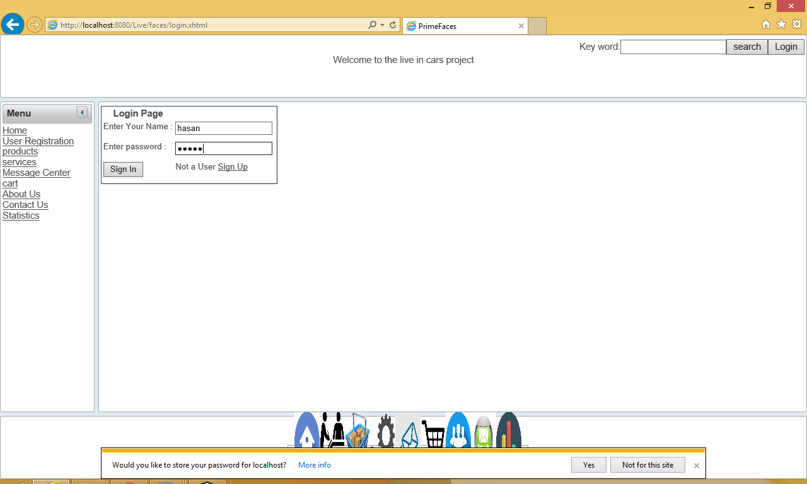

Figure 4: Login Page

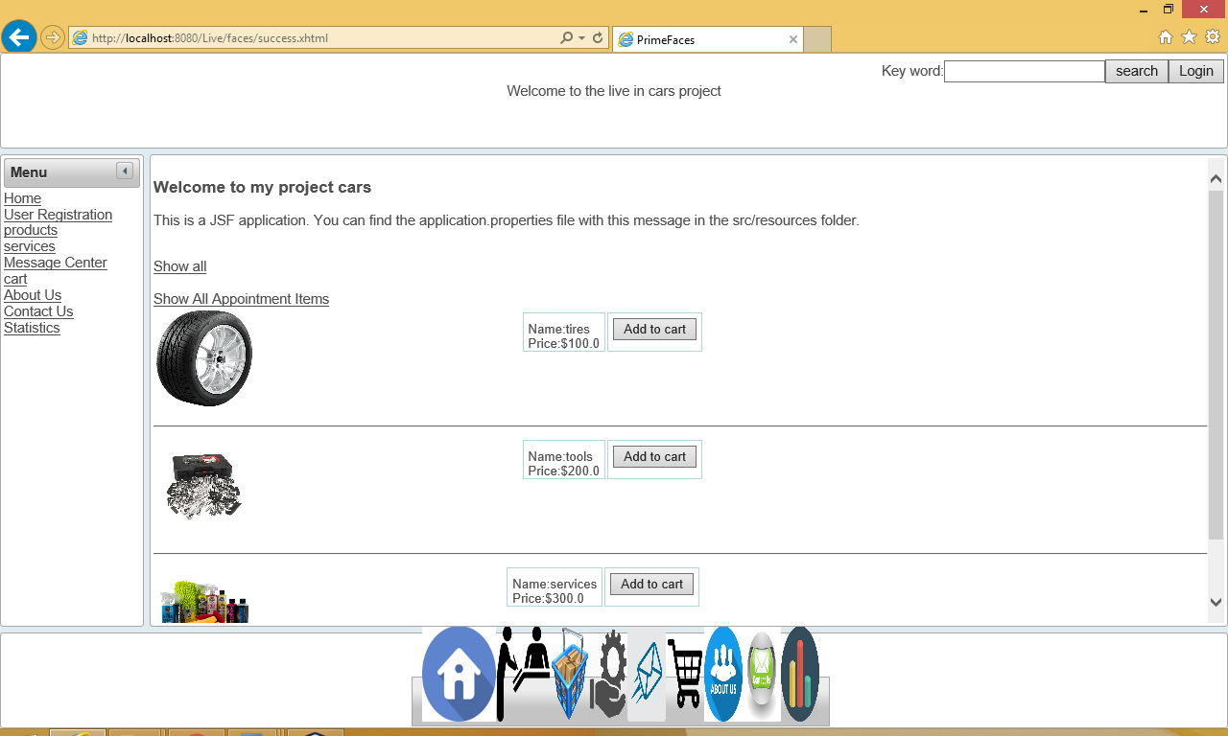

Figure 5: products of our applications

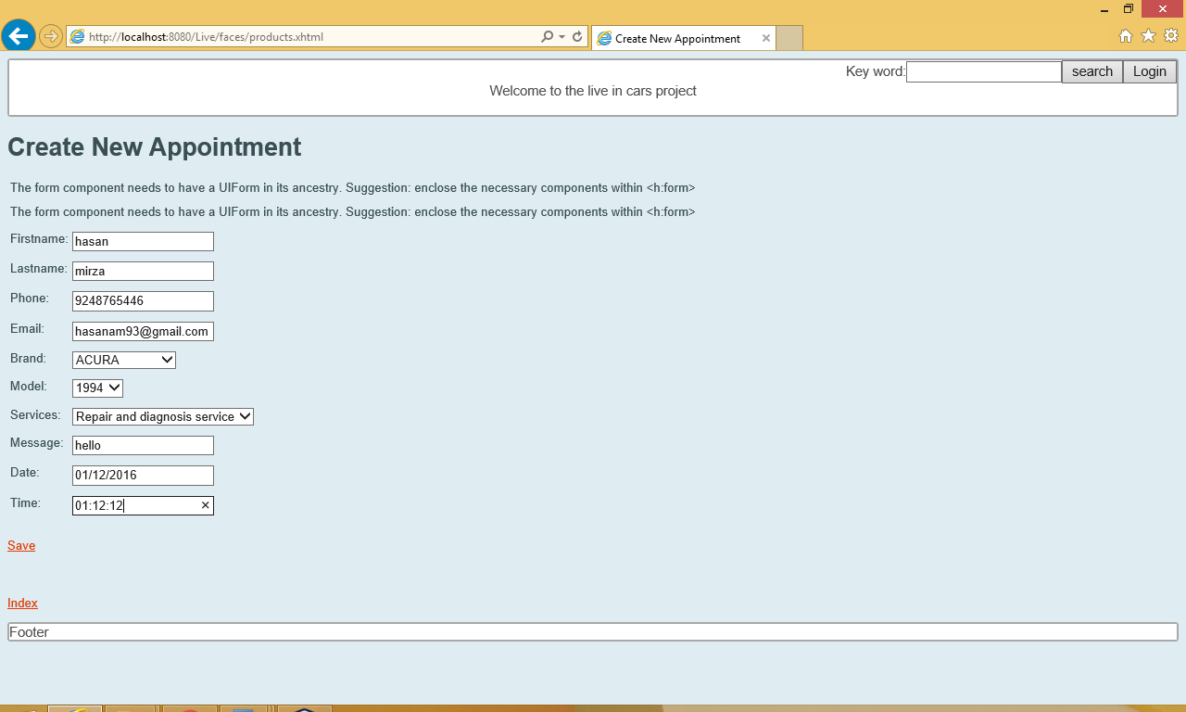

Figure 6 : Create Appointment of our application

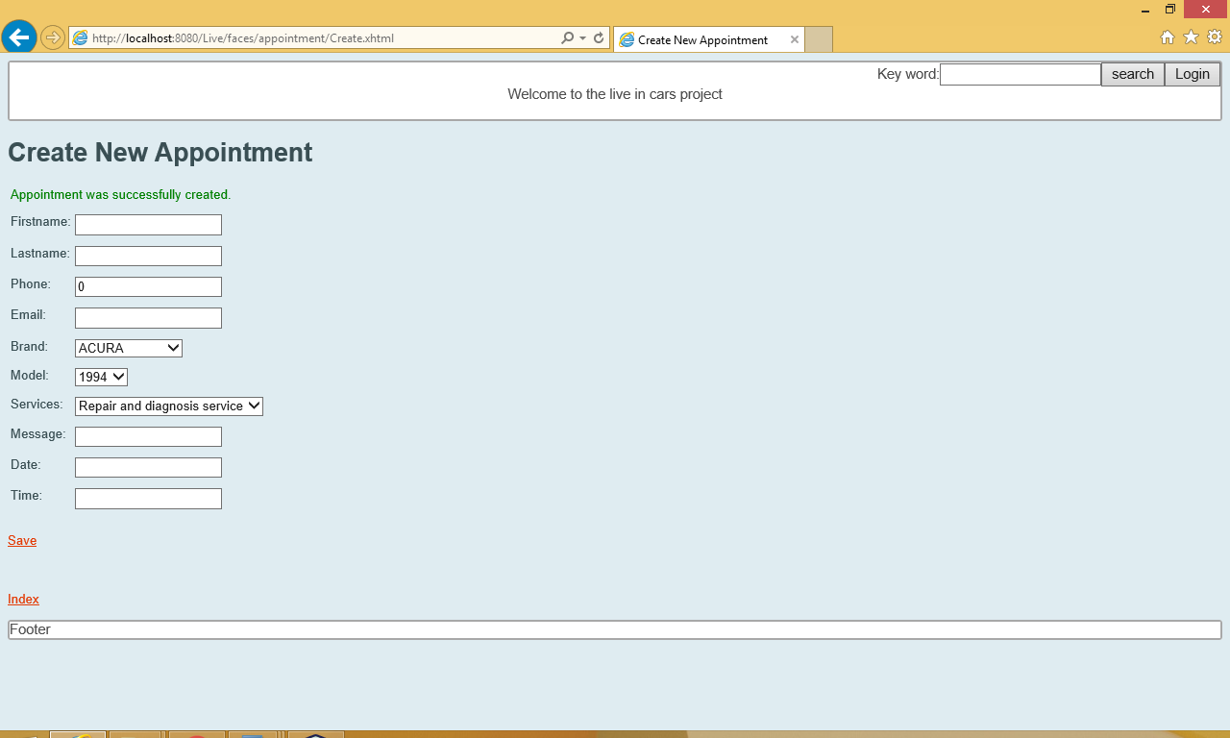

Figure 7 : appointment successfully saved

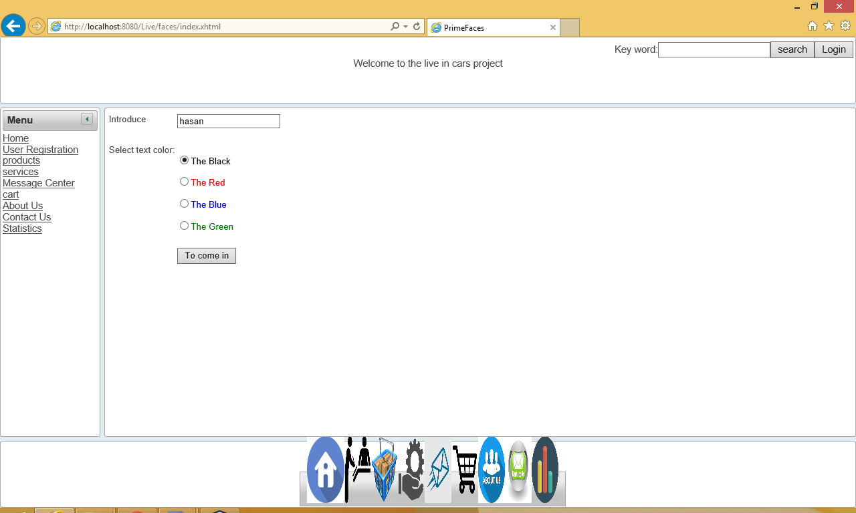

Figure 8 : message center where username and chat text color is chosen

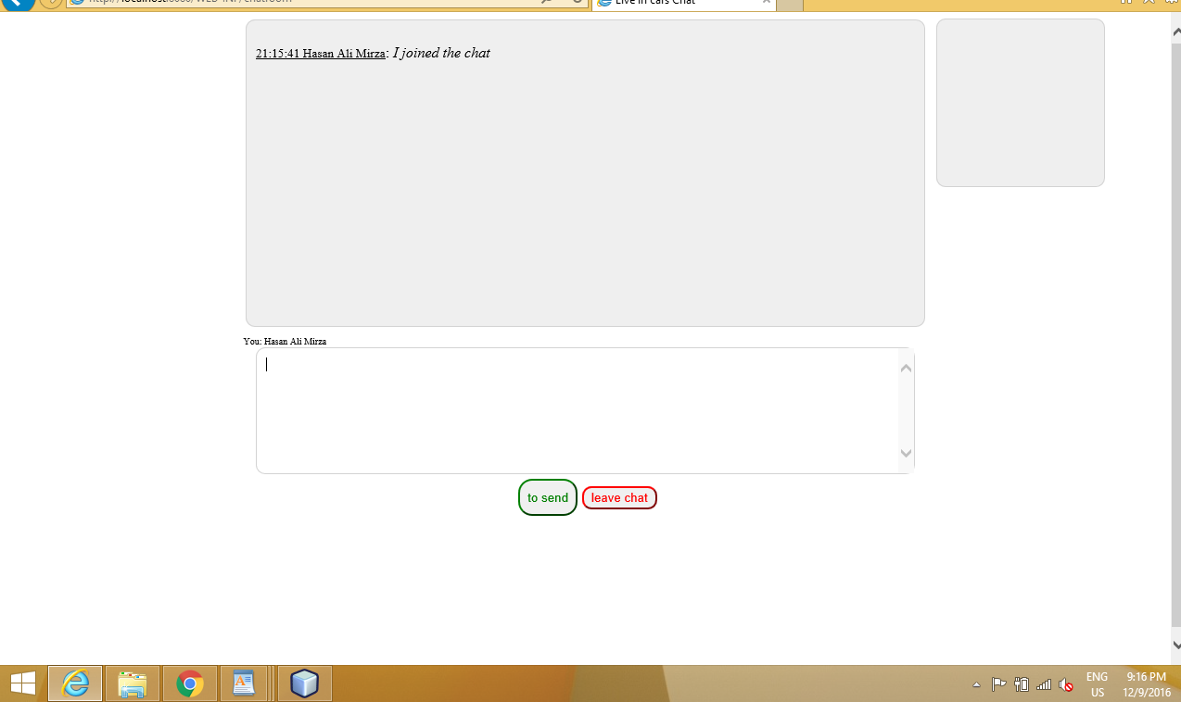

Figure 9 : where you can chat with admin

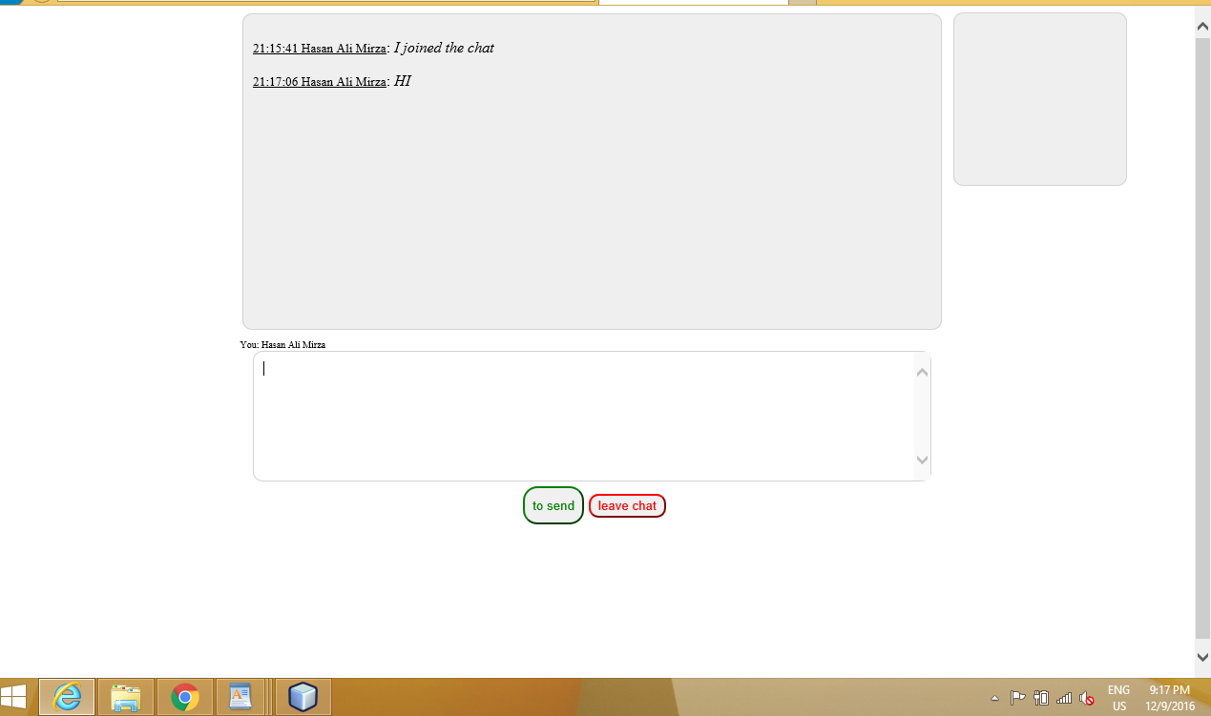

Figure 10 : type hi in the message box

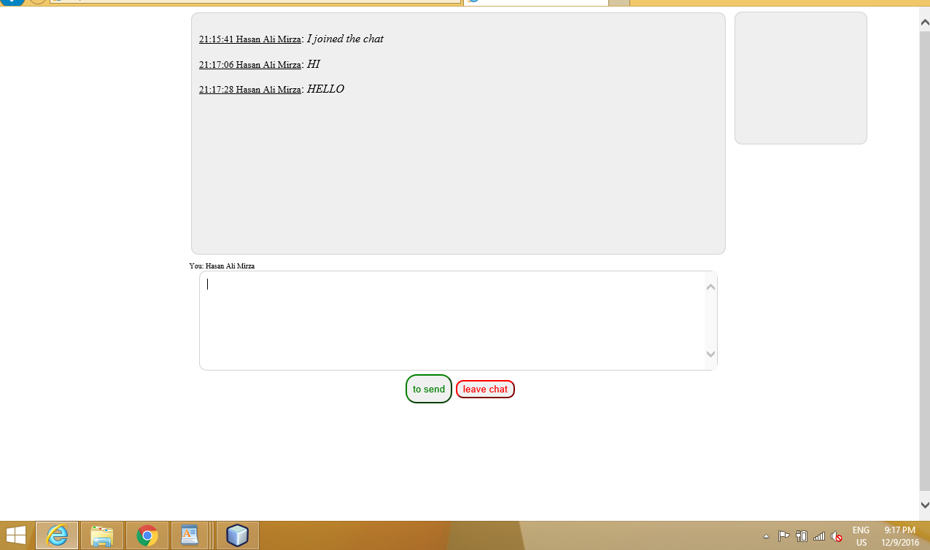

Figure 11: typed another message hello

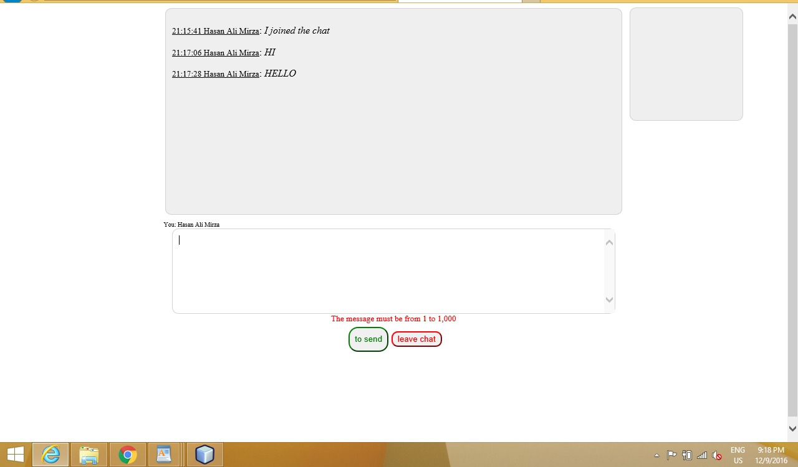

Figure 12: typed nothing it shows validation alteast 1 character to 1000

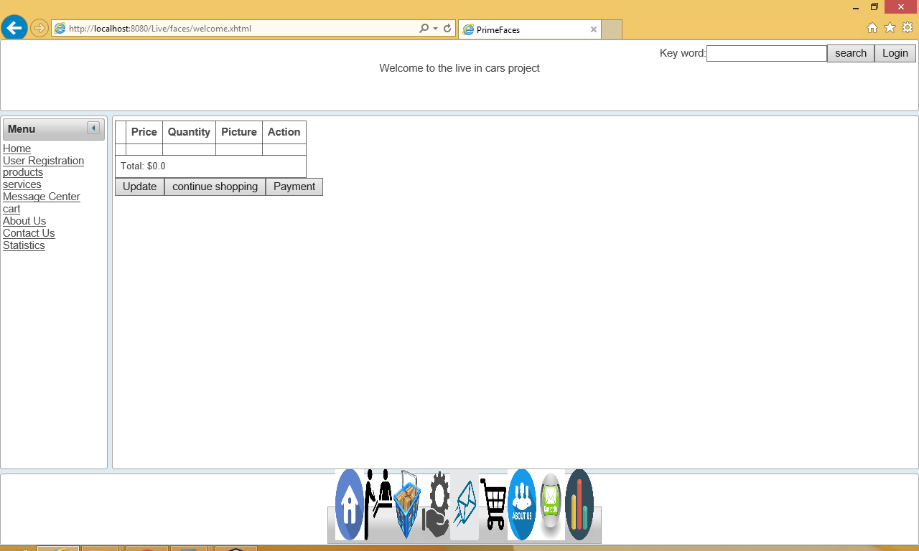

Figure 13 : cart empty of our applications

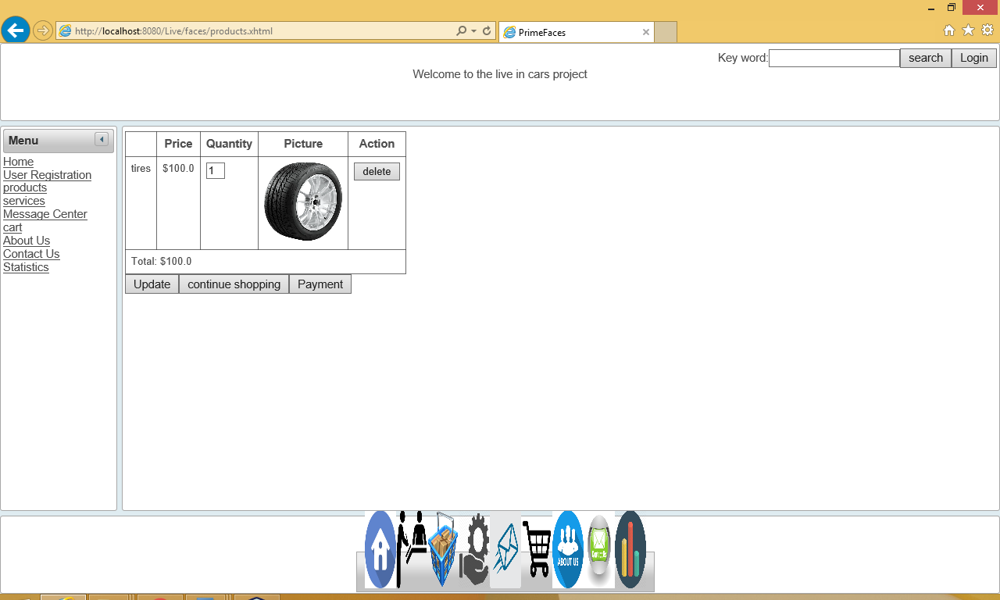

Figure 14 : click continue shopping and added one product

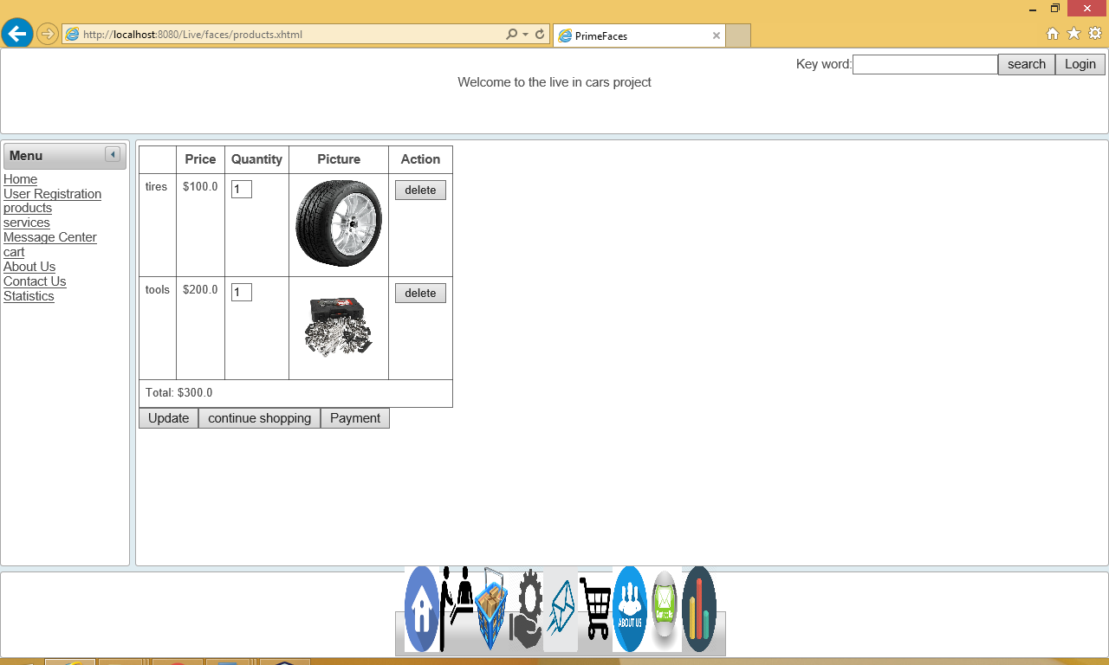

Figure 15: added second product by continuing shopping

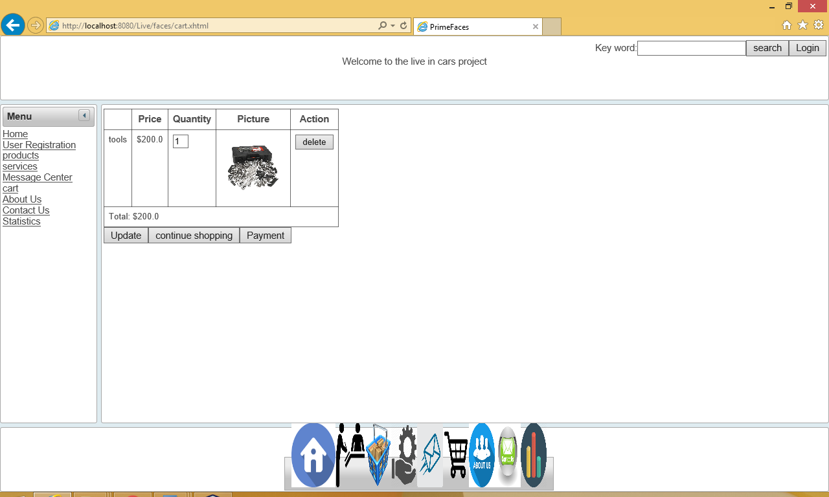

Figure 16: Deleted one item from the cart

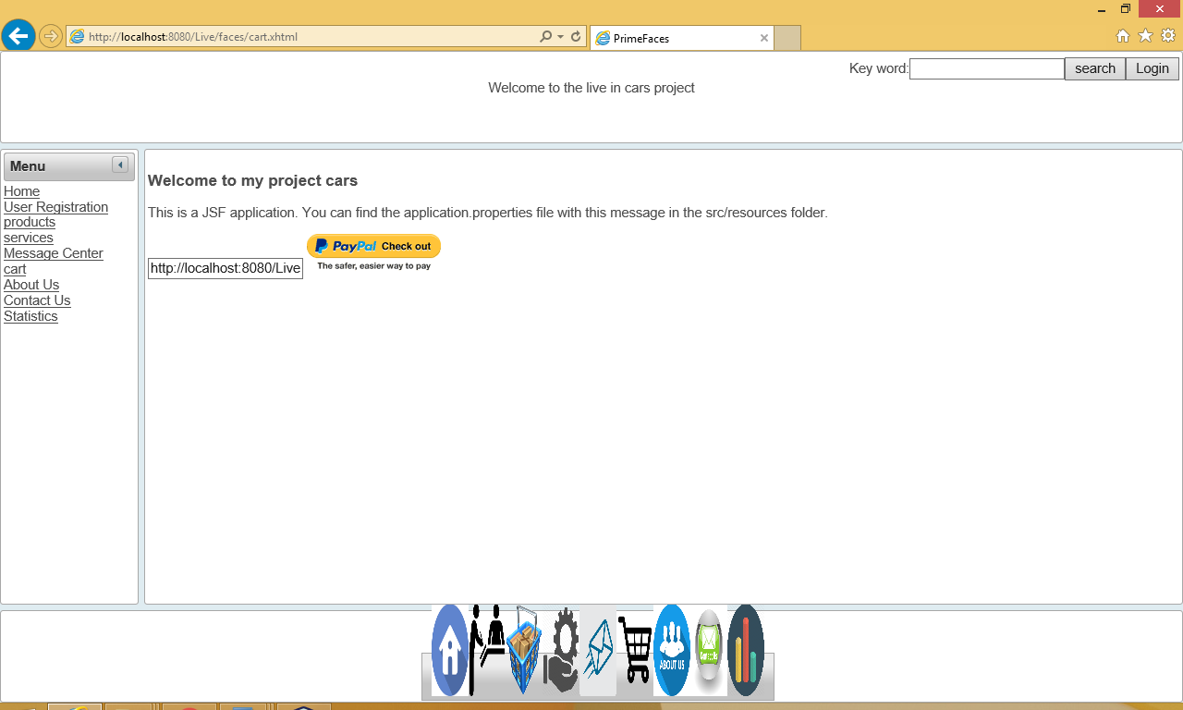

Figure 17 : payment of the cart

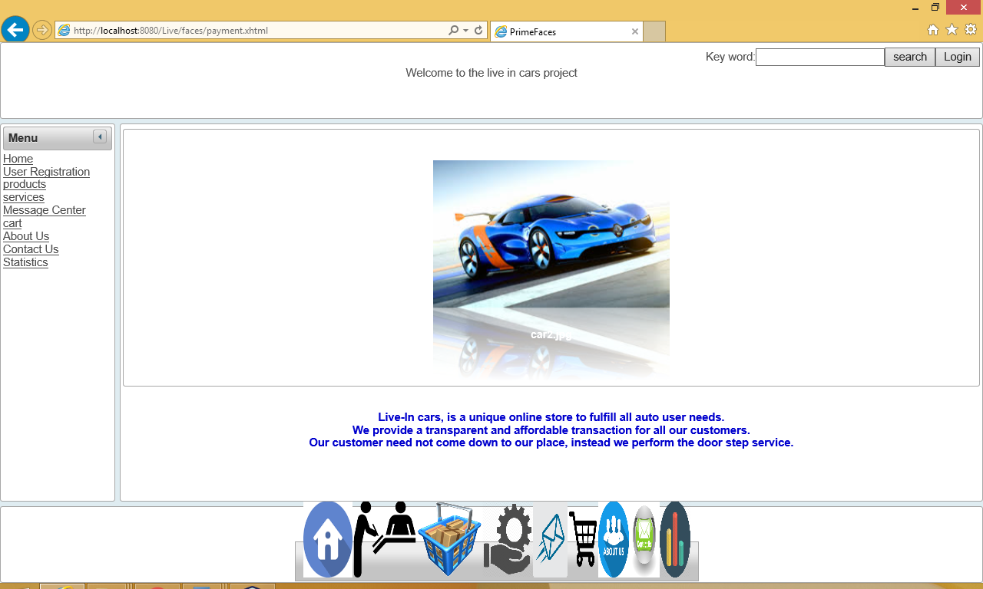

Figure 18: About us (briefly explained of company)

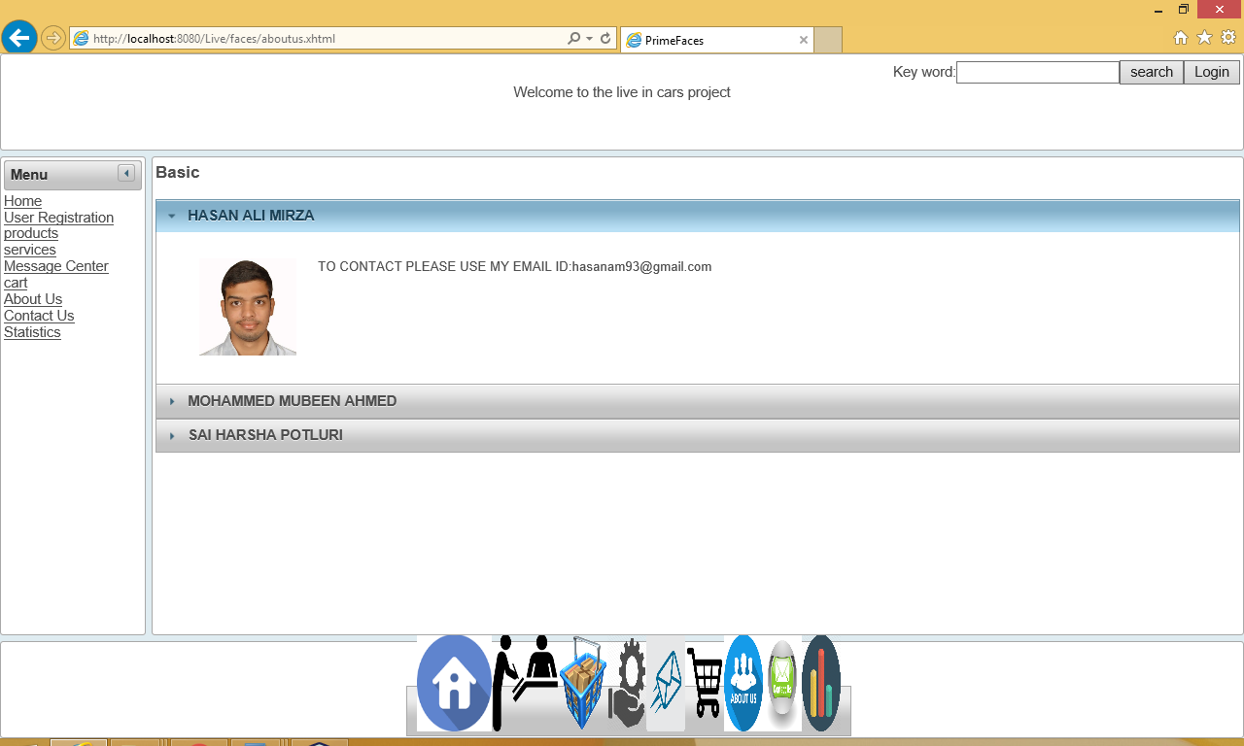

Figure 19: contact us (contact information of the company members)

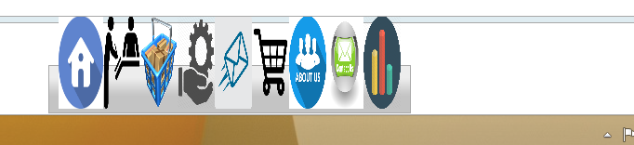

Figure 20:Dock of the footer

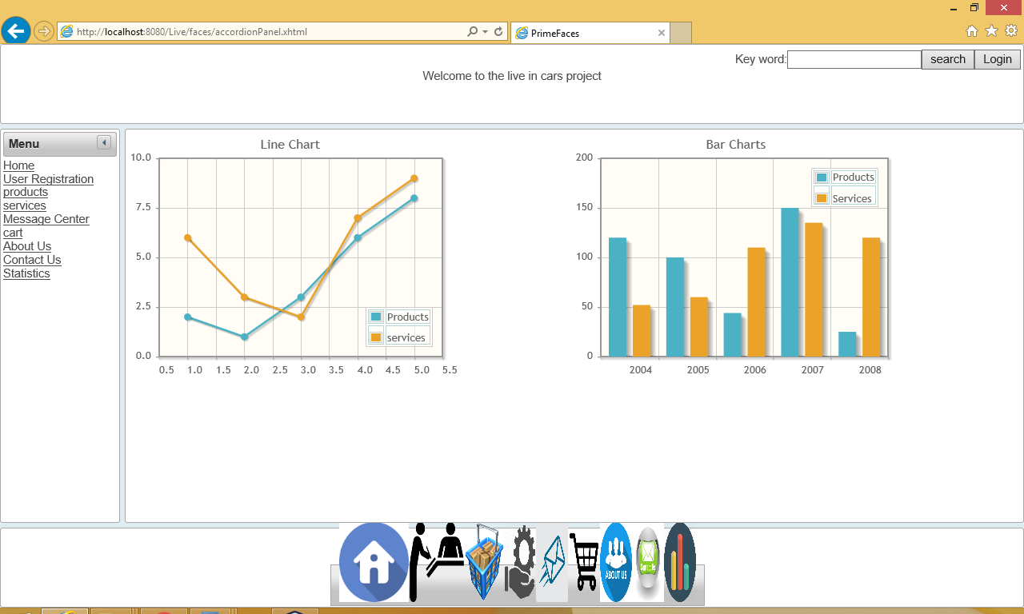

Figure 21 : statistics of the sales in live in cars company

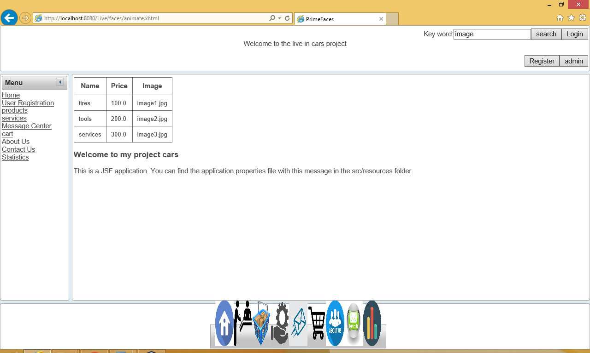

Figure 22: search button used to search products in our application

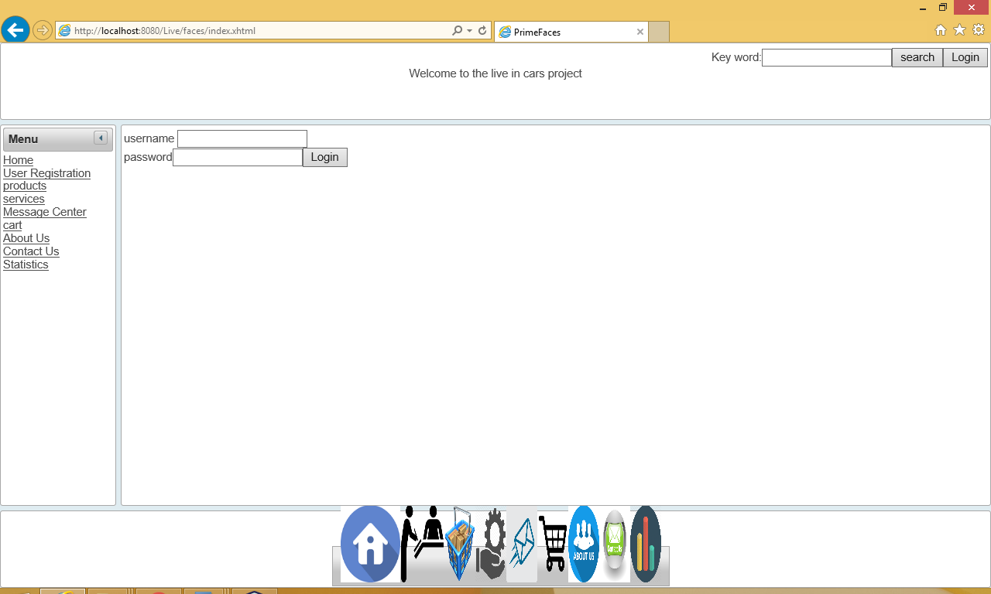

Figure 23: Admin login

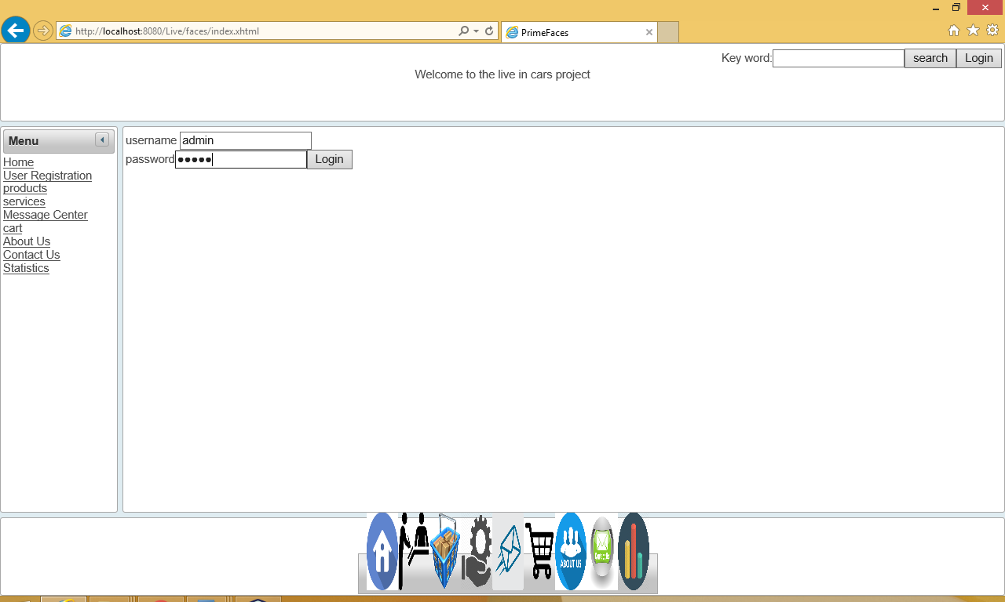

Figure 24: admin login username is admin and password is admin

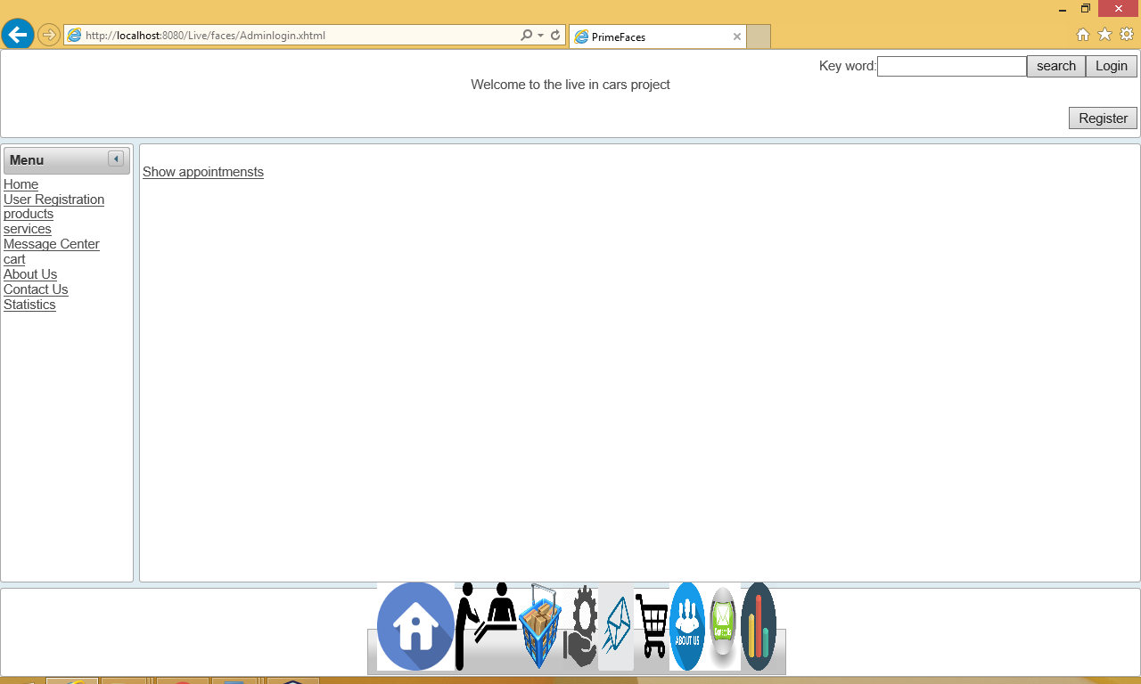

Figure 25:Admin controls the appointment

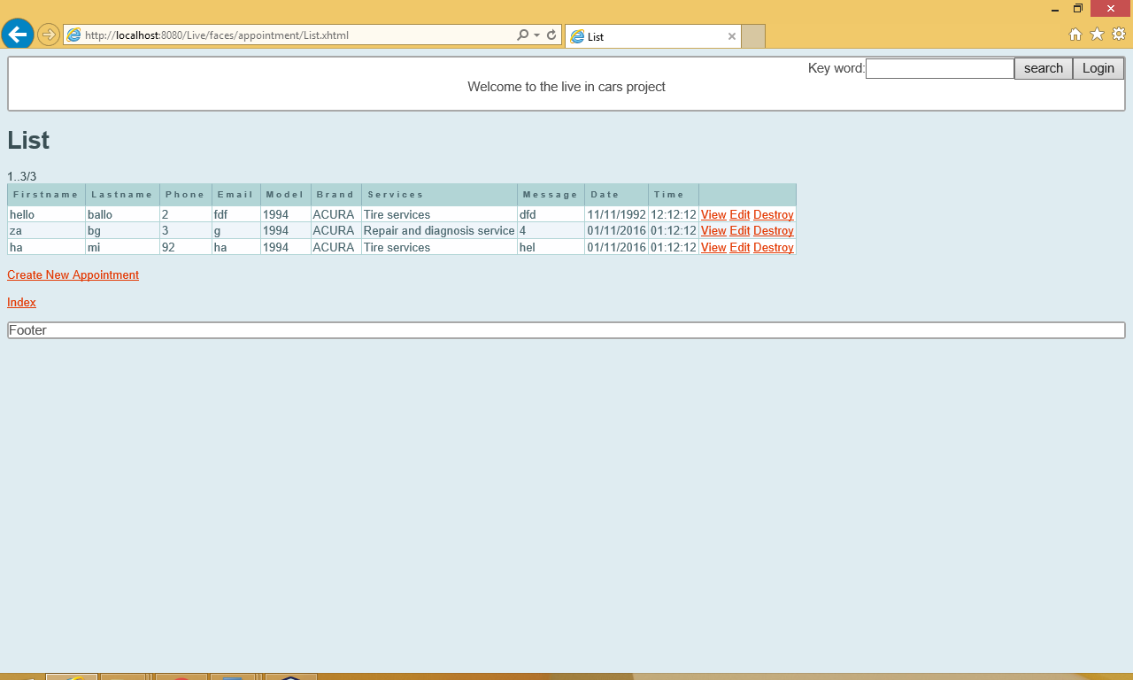

Figure 26 : appointment list where we can view edit and destroy the appointments

**CONCLUSION**

Well, after implementing this application. We can strongly say future of auto needs can be innovated. We don’t say that, here everything has been addressed and innovated. But, form now can look at things differently. Orthodox methods can be answered with modern solutions. Technology can address all issues. There cannot be a particular to solution to all problems. The solution set will change with the time. So, updating yourself and grabbing the market was the major idea behind this application.

**REFERENCES**

* [**http://www.primefaces.org/showcase/**](http://www.primefaces.org/showcase/)
* [**http://www.youtube.com/jsftutorials**](http://www.youtube.com/jsftutorials)
* [**https://www.youtube.com/results?search_query=mastering+primefaces+tutorial**](https://www.youtube.com/results?search_query=mastering+primefaces+tutorial)